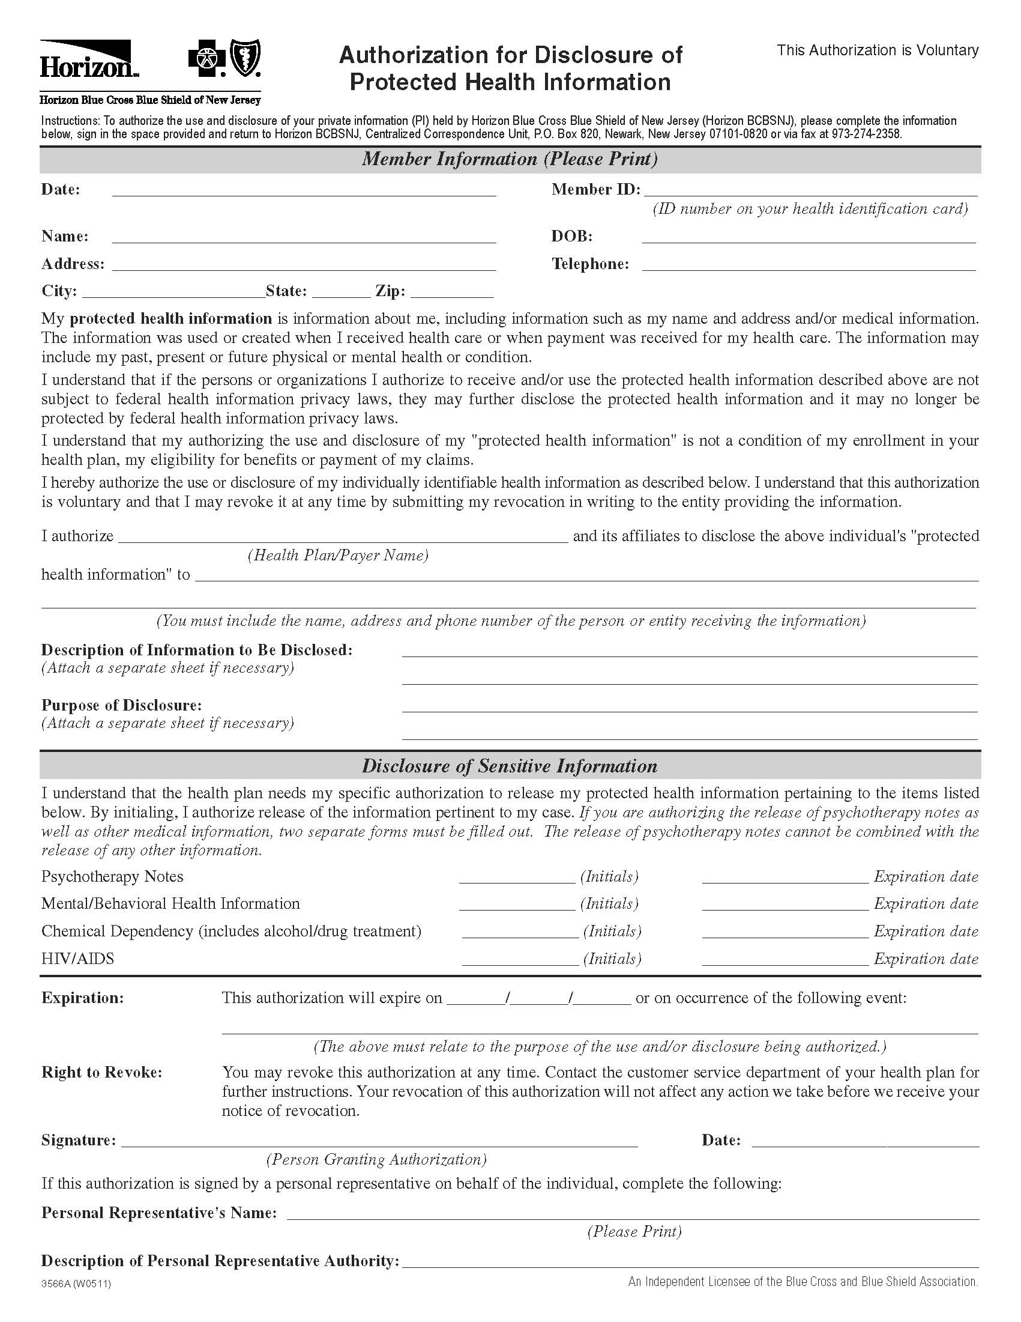

`
Order No. 01-26121 - 009
Zonnie Fritsche
1104 Premont Ave.

Upon the final adjudication of the following matter Fritsche vs. Ward & Citizens Litigation/Arbitration

Frank Penzato, Esquire, The Hanover Law Group, c/o Axiom Requisition Copy Service, 2869 Jolly Rd, Okemos, MI 48864, (877) 886-5090 / Fax (517) 886-4116 / records@axiomcopy.com
United States Treasury

Legal Matter Fritsche vs. Ward & Citizens

COPIES OF TAX RETURNS pertaining to Zonnie Fritsche SSN: XXX-XX-8263, DOB: 01/16/1965 for the following years: 2007-2010.

Waterford
MI
48328

01/16/1965

